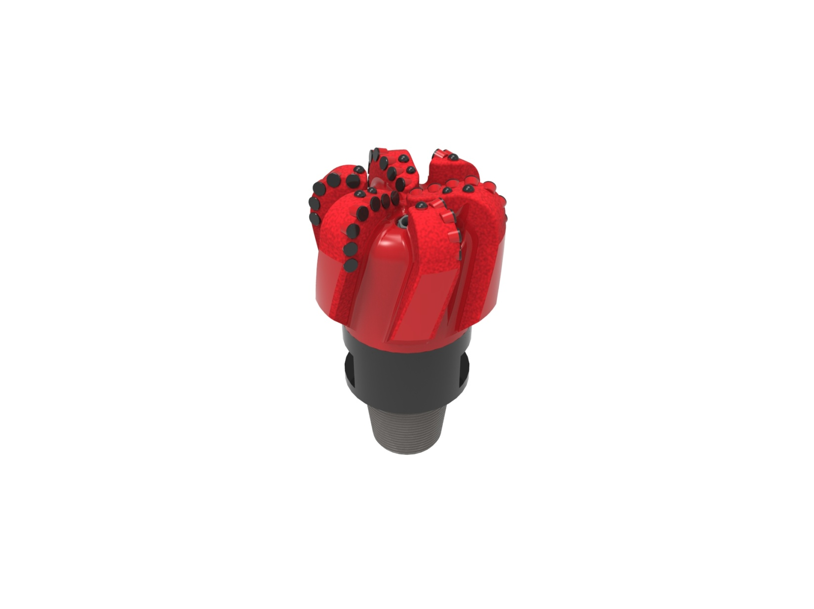

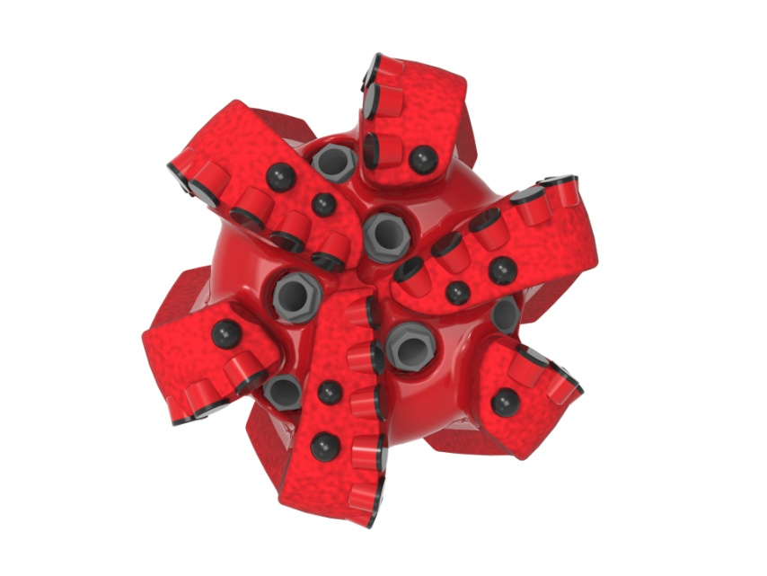

Drill Bit Specifications:
Cutter Size (Primary, Sec) | 5/8”
Cutter Count (Total, Gage) | 34,6
Blade Count | 6
Gage Length (Inches) | 3.00
Nozzle Count (Primary, Sec.) | 6
Nozzle Series (Primary, Sec.) | 60
JSA (Sq. Inches) | 14.80
Max. TFA (Sq. Inches) | 2.23
Operating Parameters:
Max. Weight on Bit (1,000 Lbs.) | 60
Make-up Torque (ft/lbs) | 17,399
Nominal Dimensions:
Overall Length (Inches) | 15.12
Make Up Length (Inches) | 11.06
Bit Breaker | SKB-21010
Connection | Ø4-1/2" API Reg.
Approx. Weight (Lbs.) | 120

Standard Features:

- Premium grade cutters maximize ROP and Life
- Large open face volume assists cuttings removal
- Six nozzles optimize blade cleaning and cuttings removal

616-SR(K) Nomenclature Explained:

• | 6 | = | Number of blades
• | 16 | = | Primary Cutter Size (16mm)
• | SR | = | Single Row of Cutters
• | K | = | Bullets


